SELECT

1. Write a query to display the names (first_name, last_name) using alias name "First Name", "Last Name"

Ans: SELECT first_name AS 'First Name', last_name AS 'Last Name' FROM employees;

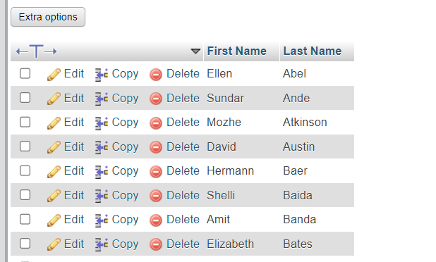

1. Write a query to get unique department ID from employee table.

Ans:- SELECT DISTINCT DEPARTMENT_ID FROM employees;

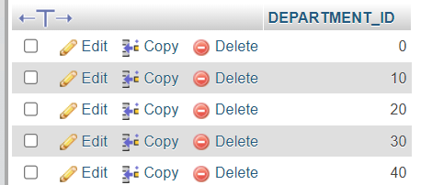

1. Write a query to get all employee details from the employee table order by first name, descending.

Ans:- SELECT * FROM employees ORDER BY FIRST_NAME DESC

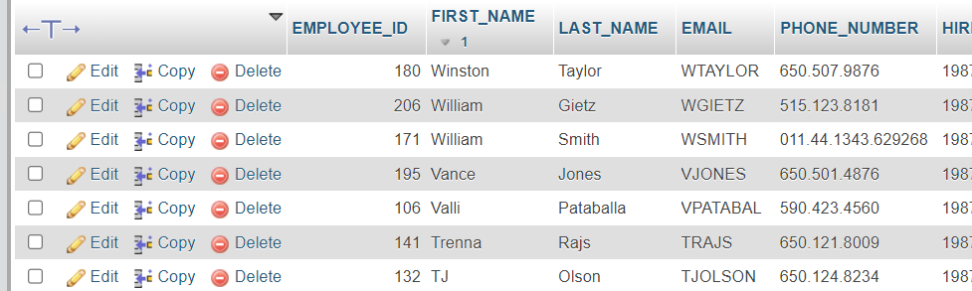

1. Write a query to get the names (first_name, last_name), salary, PF of all the employees (PF is calculated as 15% of salary).

Ans:- SELECT FIRST_NAME,LAST_NAME,SALARY, SALARY*0.15 AS PF FROM employees;

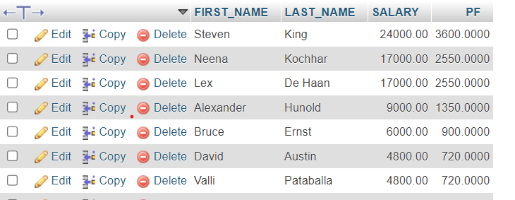

1. Write a query to get the total salaries payable to employees.

Ans :- SELECT SUM(salary) FROM employees;

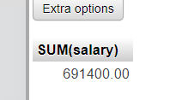

1. Write a query to get the employee ID, names (first_name, last_name), salary in ascending order of salary.

Ans:- SELECT EMPLOYEE_ID, FIRST_NAME, LAST_NAME, SALARY FROM employees ORDER BY SALARY;

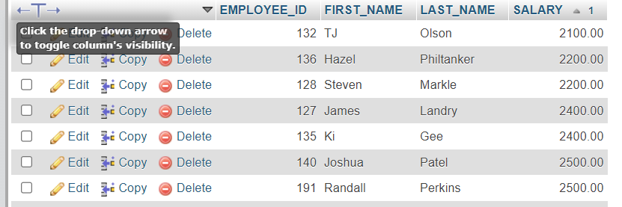

1. Write a query to get the maximum and minimum salary from employees table.

Ans:- SELECT MAX(SALARY), MIN(SALARY) FROM employees;

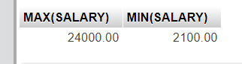

1. Write a query to get the average salary and number of employees in the employees table.

Ans:- SELECT AVG(SALARY), COUNT(SALARY) FROM employees;

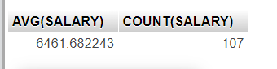

1. Write a query to get the number of employees working with the company.

Ans:- SELECT COUNT(EMPLOYEE_ID) FROM employees;

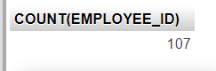

1. Write a query to get the number of jobs available in the employees table.

Ans:- SELECT COUNT(DISTINCT JOB_ID) FROM employees;

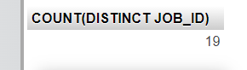

1. Write a query get all first name from employees table in upper case.

Ans:- SELECT UCASE(FIRST_NAME) AS FIRST_NAME FROM employees;

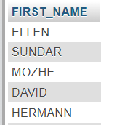

1. Write a query to get the first 3 characters of first name from employees table.

Ans:- SELECT SUBSTRING(FIRST_NAME,1,3) FROM employees

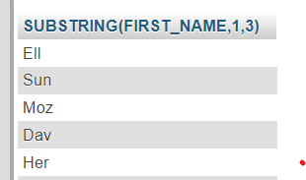

1. Write a query to calculate 171*214+625.

Ans:- SELECT 171*214+625 RESULT;

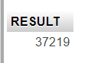

1. Write a query to get the names (for example Ellen Abel, Sundar Ande etc.) of all the employees from employees table.

Ans:- SELECT CONCAT(FIRST_NAME,' ',LAST_NAME) FROM employees;

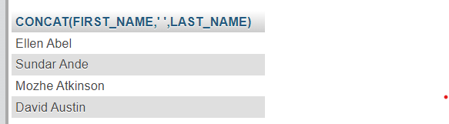

1. Write a query to get first name from employees table after removing white spaces from both side.

Ans:- SELECT TRIM(FIRST_NAME) FROM employees;

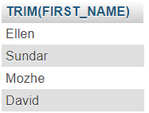

1. Write a query to get the length of the employee names (first_name, last_name) from employees table.

Ans:- SELECT LENGTH(CONCAT(FIRST_NAME,' ', LAST_NAME)) AS NAMELENGTH FROM employees;

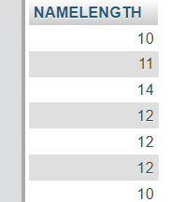

1. Write a query to check if the first_name fields of the employees table contains numbers.

Ans:- SELECT * FROM employees WHERE FIRST_NAME REGEXP'[0-9]';

No REGEXP or Output

1. Write a query to select first 10 records from a table.

Ans:- SELECT * FROM employees LIMIT 10;

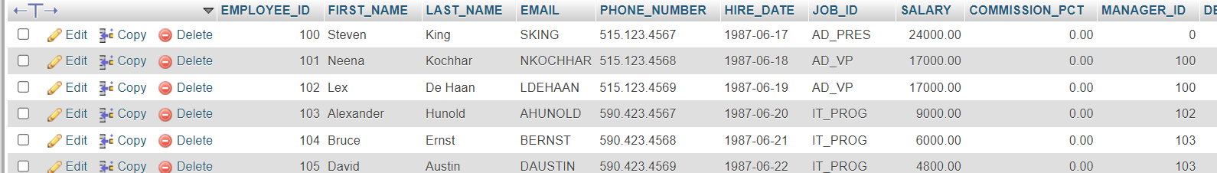

1. Write a query to get monthly salary (round 2 decimal places) of each and every employee

Ans:- SELECT FIRST_NAME, ROUND((SALARY/12),2) AS MOMONTHSALARY FROM employees;

